**IDX G9 PHY S+ STUDY GUIDE ISSUE 1**

**By Gordon**

**2.1 Reference Frames**

INTRODUCTION

* MECHANICS: study of motion and force
  + KINEMATICS: study of motion
  + DYNAMICS: study of force

1. RECOGNIZING MOTION
   1. An object is in motion if it changes POSITION relative to a FRAME OF REFERENCE
   2. Whether an object moves depends on your POV(Point of View)
   3. REFERENCE POINTS (FRAME OF REFERENCE)
      * + A PLACE OR BACKGROUND used to compare whether an object is in motion or not. (ALWAYS ASSUMED AS STATIONARY)
2. PICTURING MOTION
   1. MOTION DIAGRAM
      * + A series of a series of images showing the positions of a moving object at equal time intervals.
        + Purpose: visualize displacement and velocity
   2. PARTICLE MODEL
      * + a simplified version of a motion diagram in which the object in motion is replaced by a series of particles.

VECTORS AND SCALARS

VECTOR

* + - * Quantities which has a DIRECTION and a MAGNITUDE (size)

SCALAR

* + - * Quantities which have magnitude but no direction .

DISTANCE AND DISPLACEMENT

* + DISTANCE
    - Scalar
    - The accumulation of path
  + DISPLACEMENT
    - Vector
    - distance move in a particular DIRECTION

**2.2 + 2.3 Average Velocity + Instantaneous Velocity**

SPEED

* + Distance an object travels / unit of time
  + Formula: Speed=distance / time (v=d/t)
  + Instantaneous Speed: Speed at a particular moment

AVERAGE SPEED

* + when speed is not constant —> average speed = total distance / total time
  + when speed is constant —> constant speed motion

VELOCITY

* + speed in a given direction
  + can be shown with an arrow
  + use + or - to represent direction when move in a straight line
  + direction is very important
  + average velocity = total displacement / time
  + Instantaneous velocity : Velocity at particular instant of time

**2.4 Acceleration**

* + the rate at which an object’s velocity changes
  + a = v / t = Vf - Vi / Tf - Ti
  + instantaneous acceleration: the CHANGE in velocity at an INSTANT of time

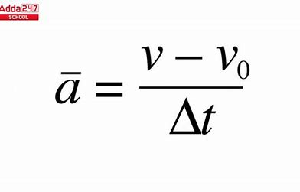**2.5 Motion at constant acceleration + 2.6 Solving Problems**Formulas

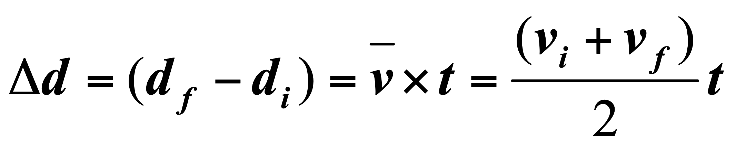

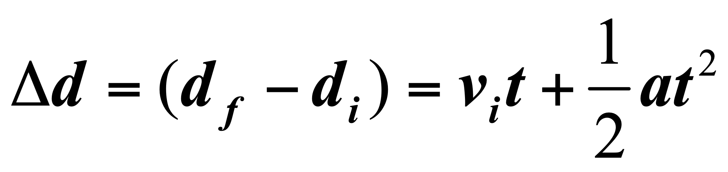

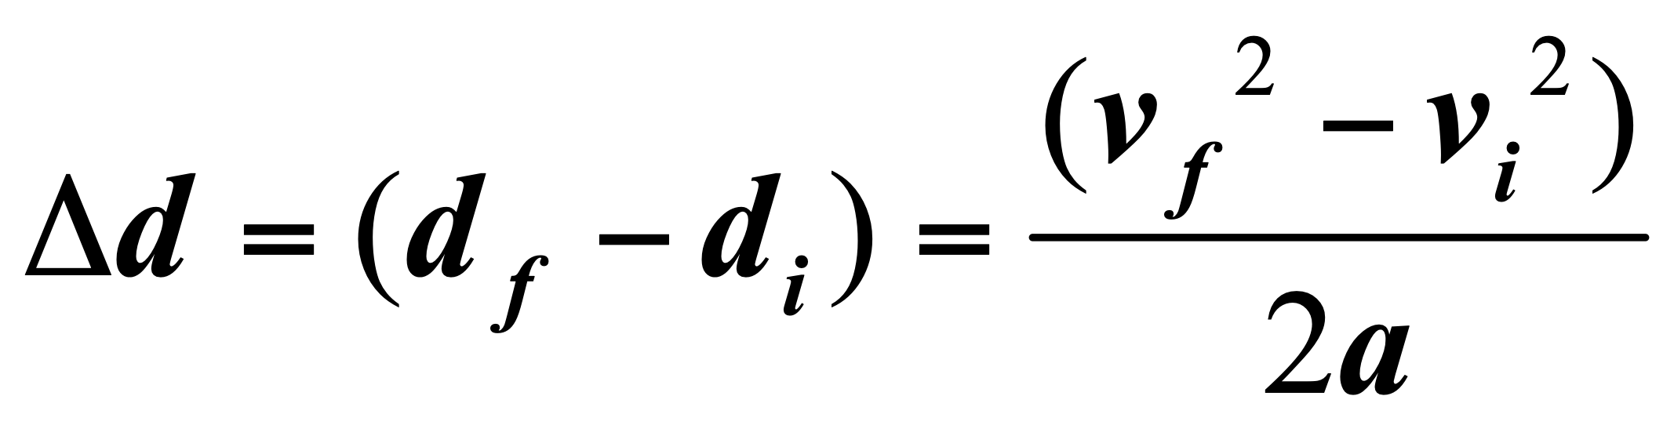

**2.7 Falling Objects**

Free Fall

* + The motion of a falling object when air resistance is negligible and the action can be considered due to gravity alone.
  + Aristotle: heavier objects falls faster
  + Galileo’s Thought Experiment
  + Galileo’s Model
    - Steeper Incline —> faster acceleration
    - Incline=vertical: Maximum Acceleration
    - All objects fall at g(g=9.8m/s^2)neglecting air resistance
  + Galileo’s Hypothesis
  + at a given location on the Earth and in the absence of air resistance, all objects fall with the same constant acceleration.

Acceleration due to gravity

* + No matter what the falling object is made of
  + No matter how much it weighted
  + No matter what height it was dropped from
  + No matter whether it was dropped down or thrown upward
  + Small variations in g at different LATITUDE and ELEVATION on earth
  + +g = downward to be positive; -g = upward to be negative

Distances of free falling from Vi=0

* + Vi=0, d=1/2gt^2